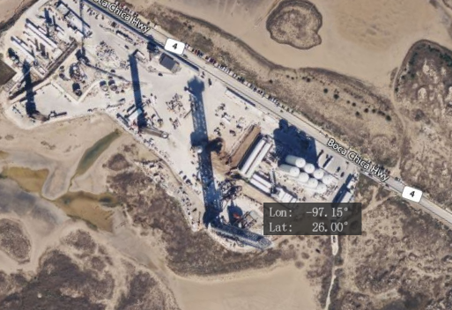

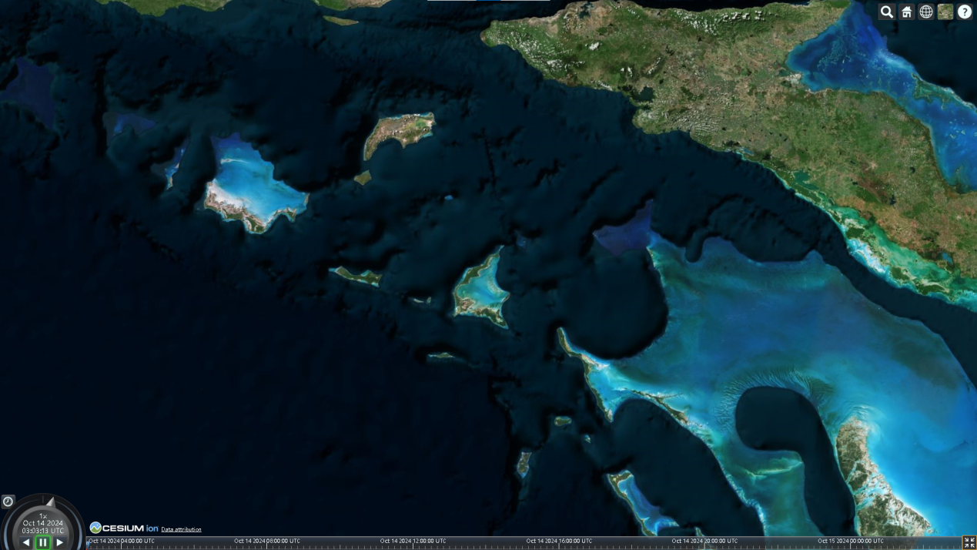

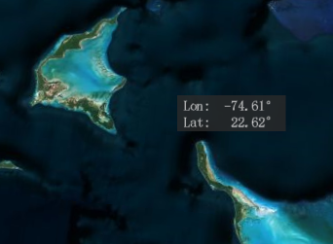

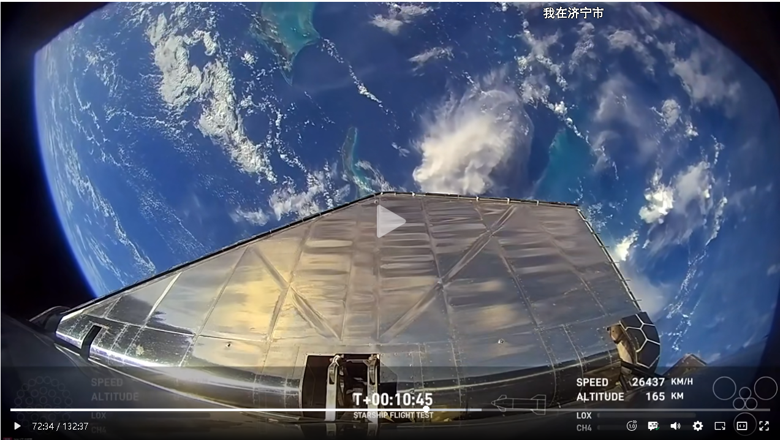

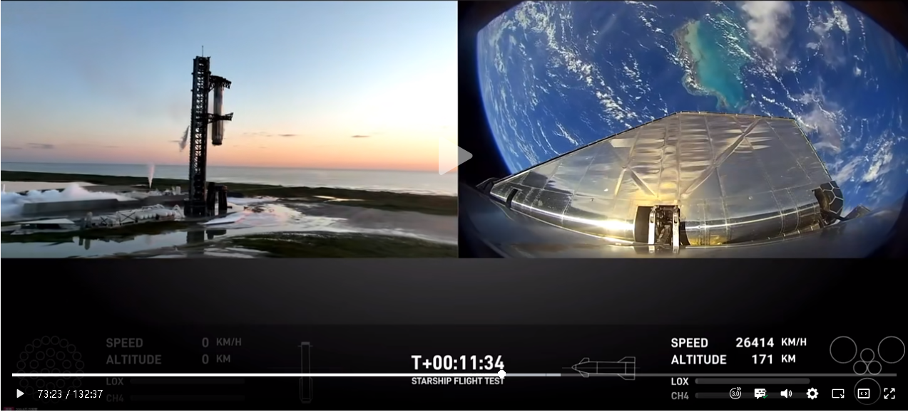

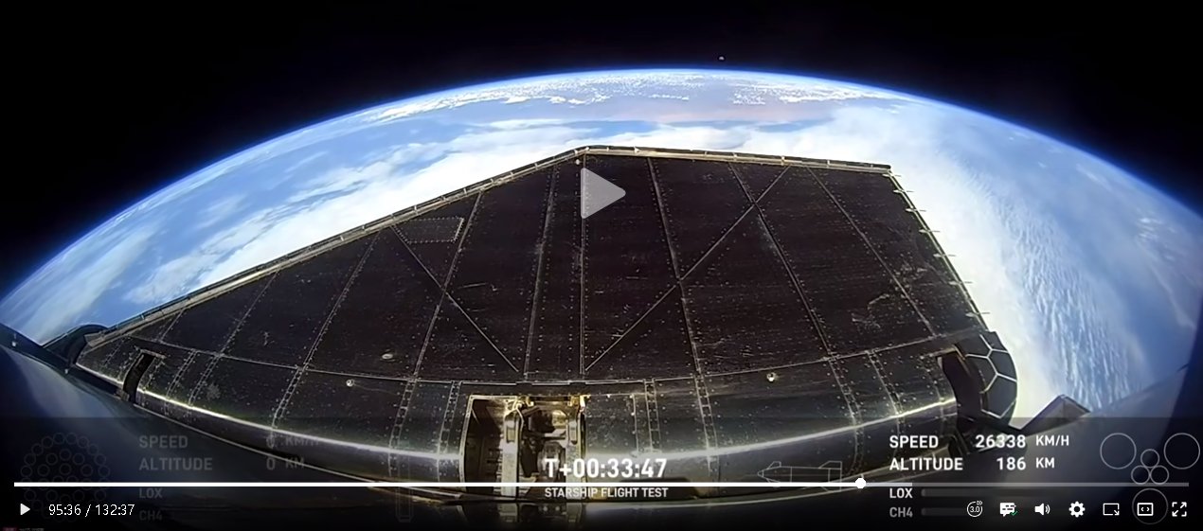

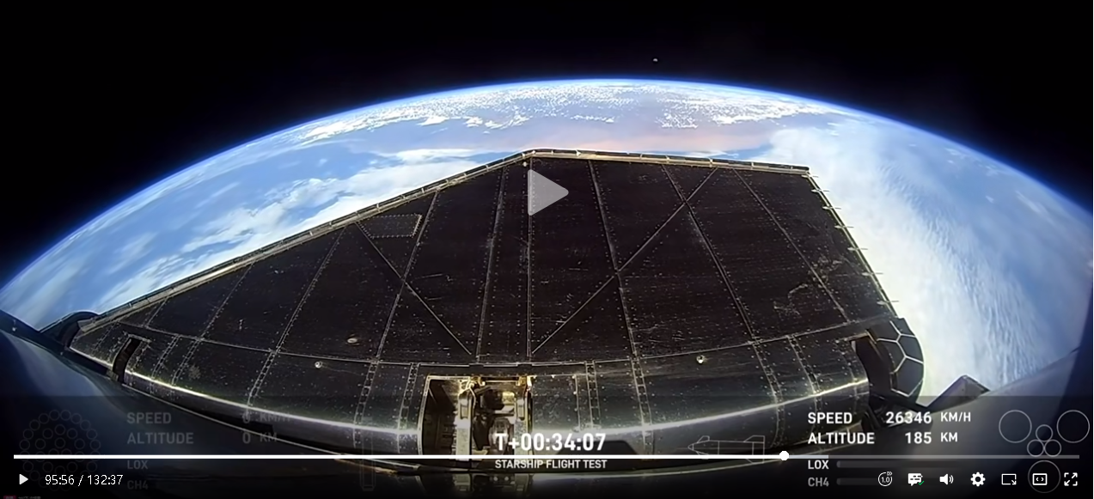

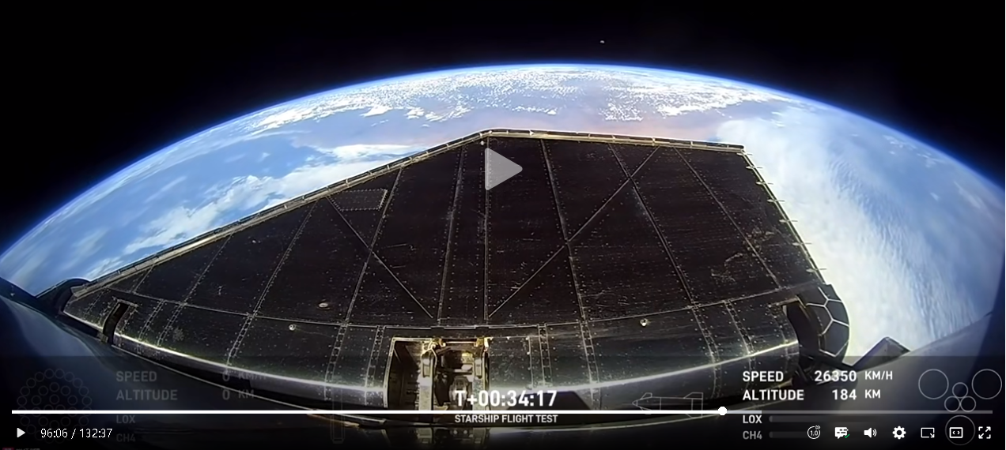

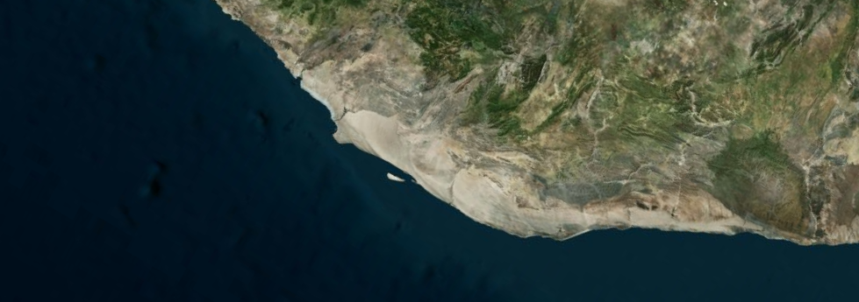

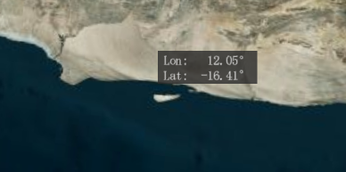

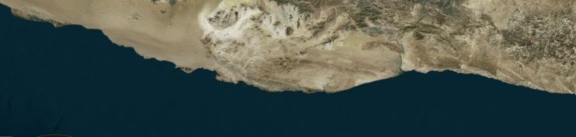

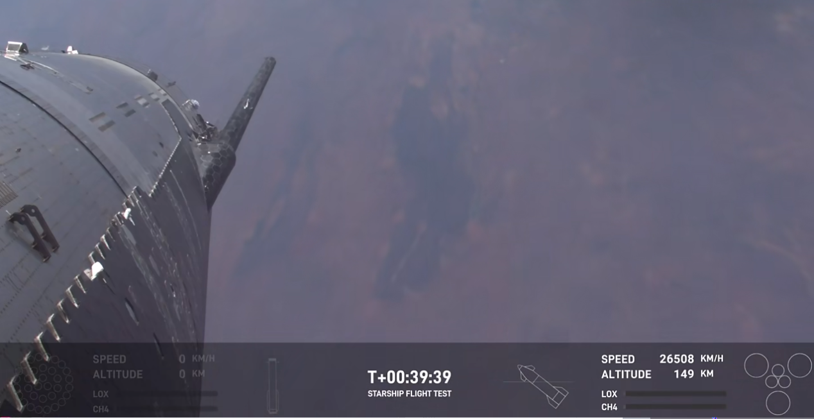

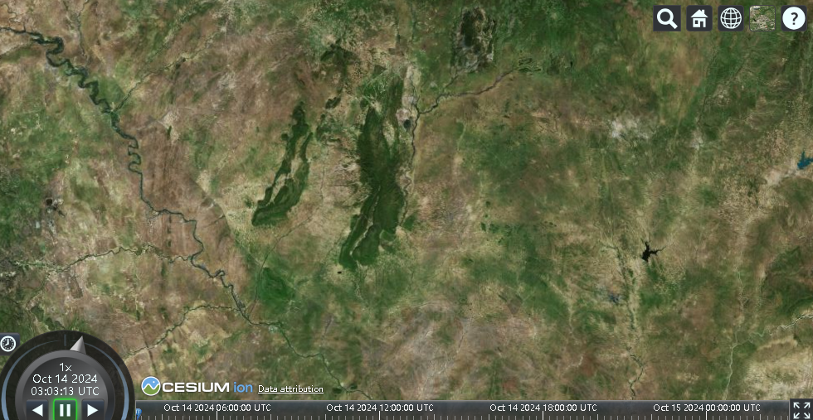

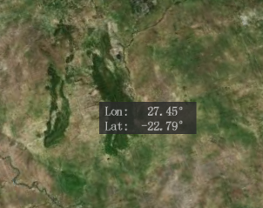

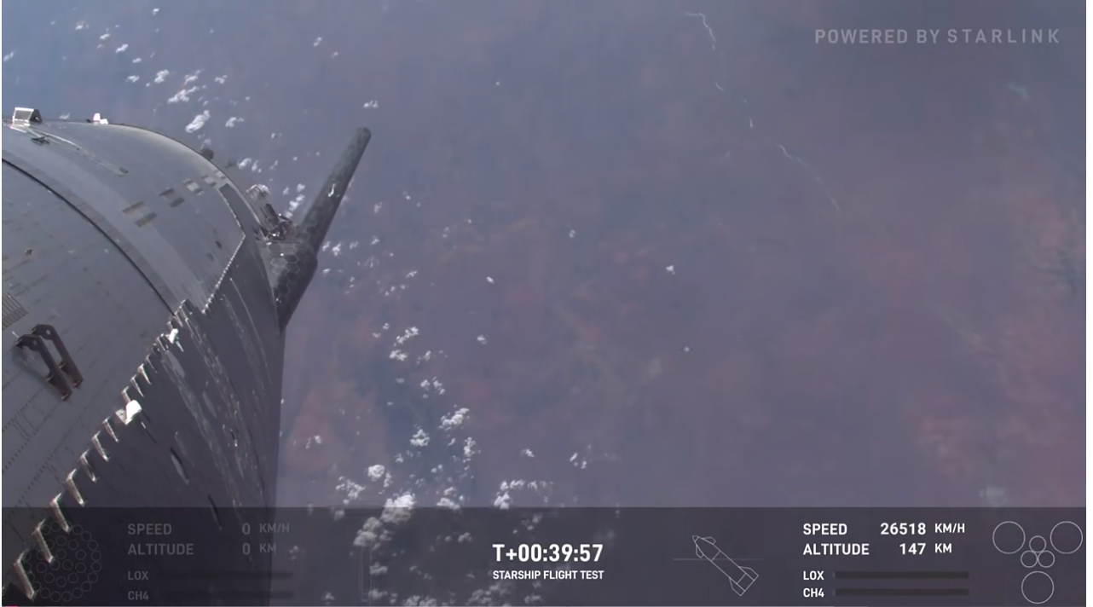

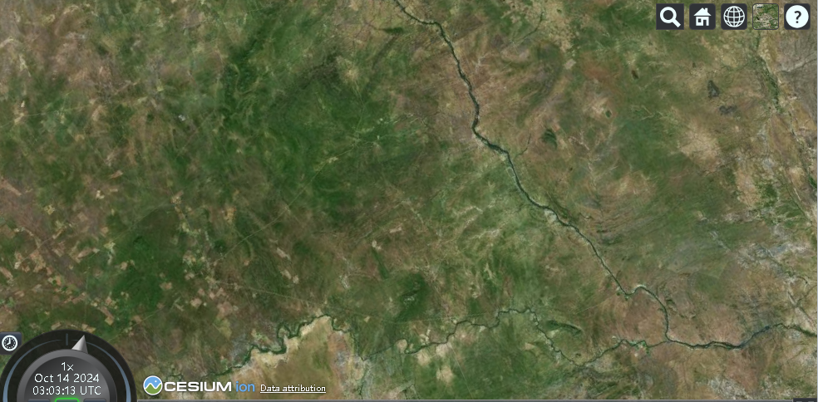

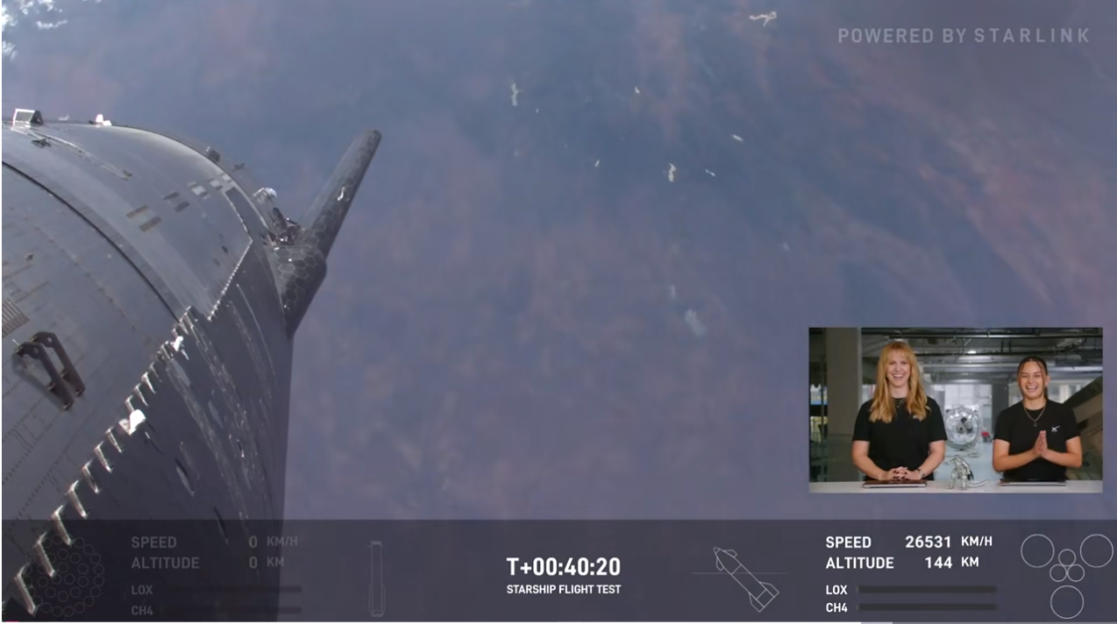

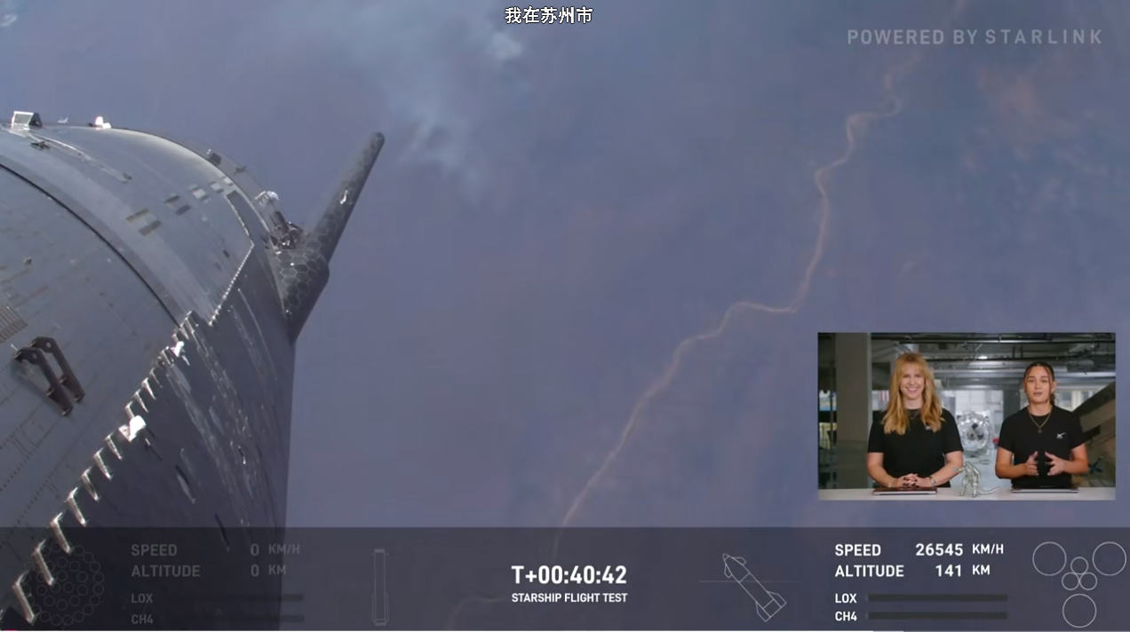

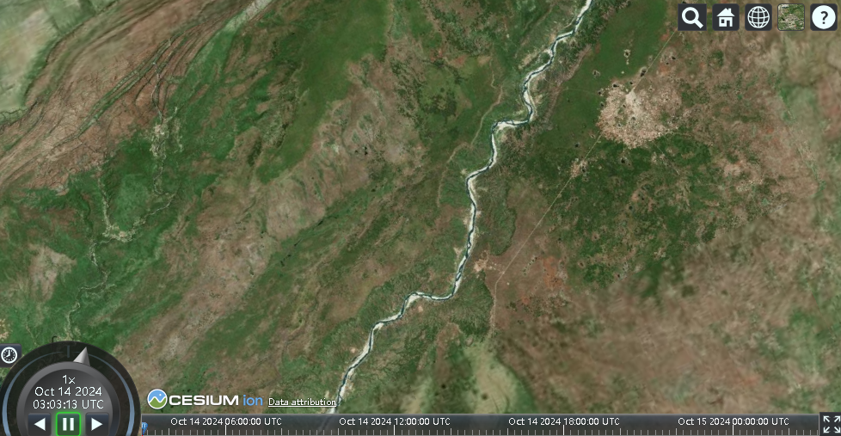

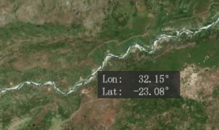

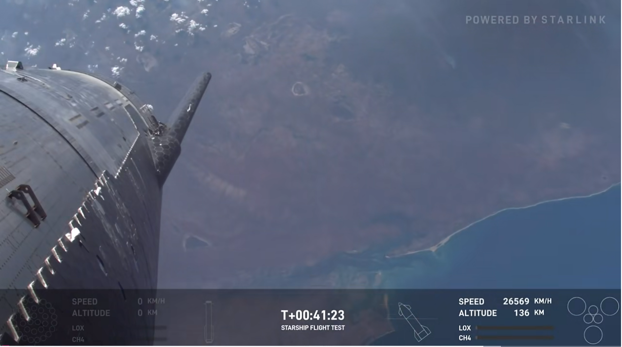

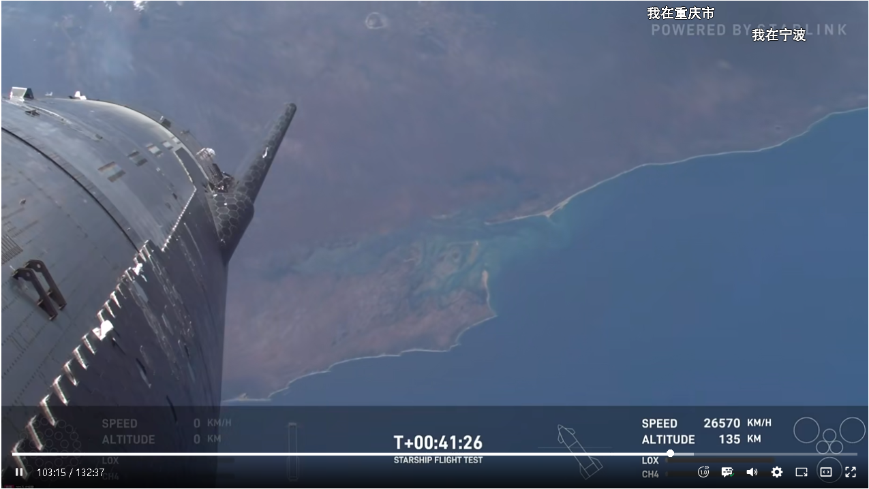

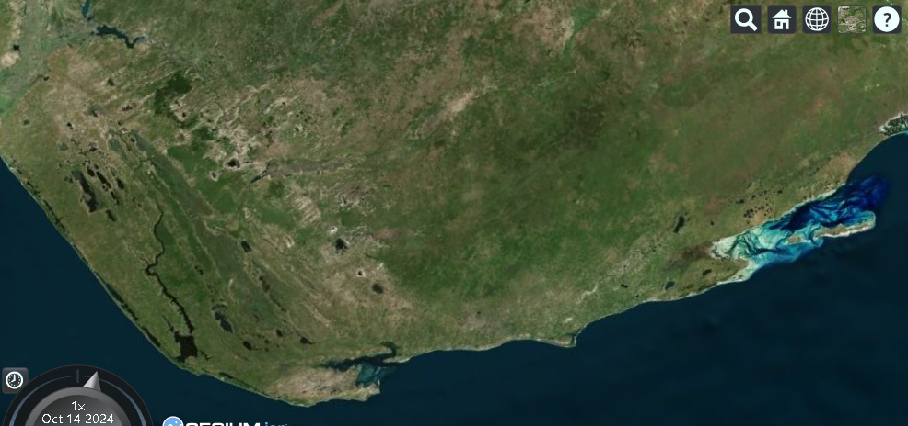

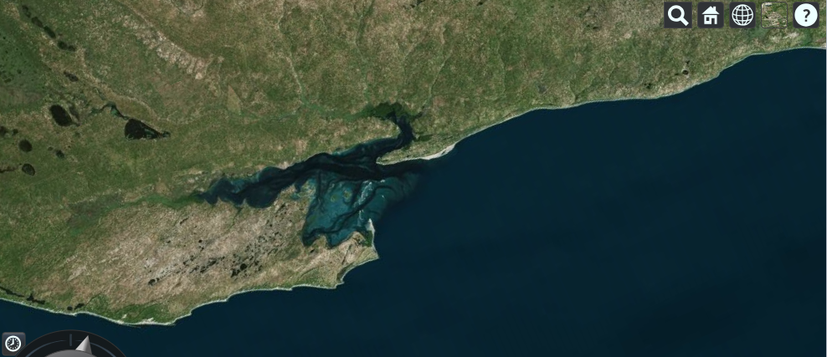

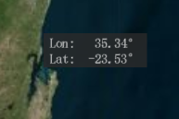

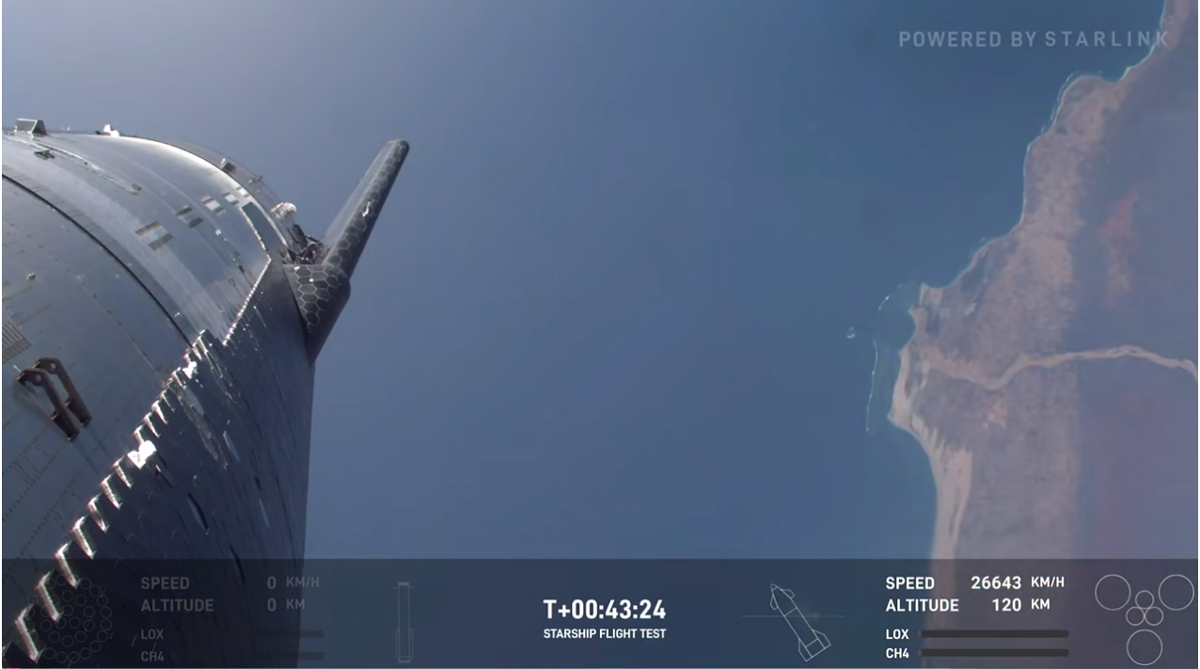

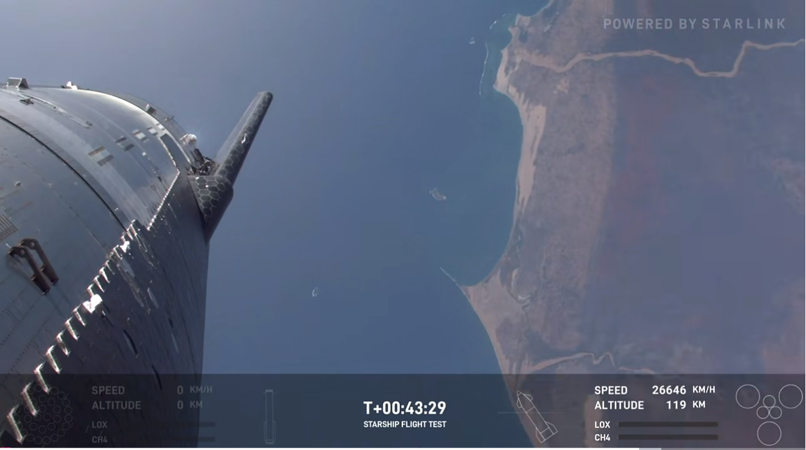

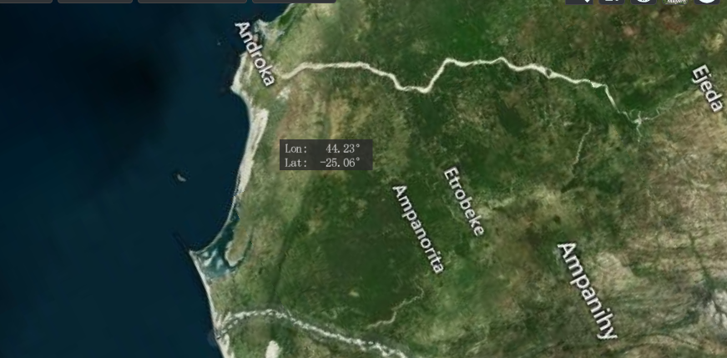

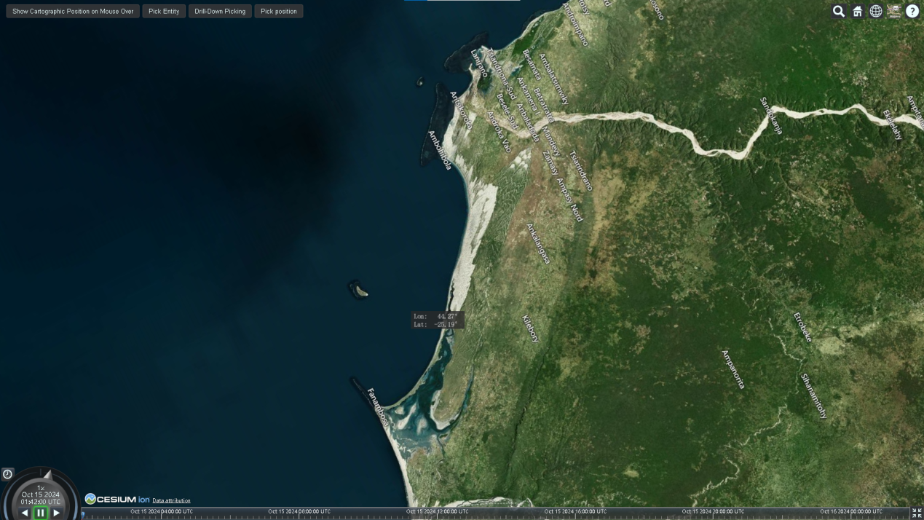

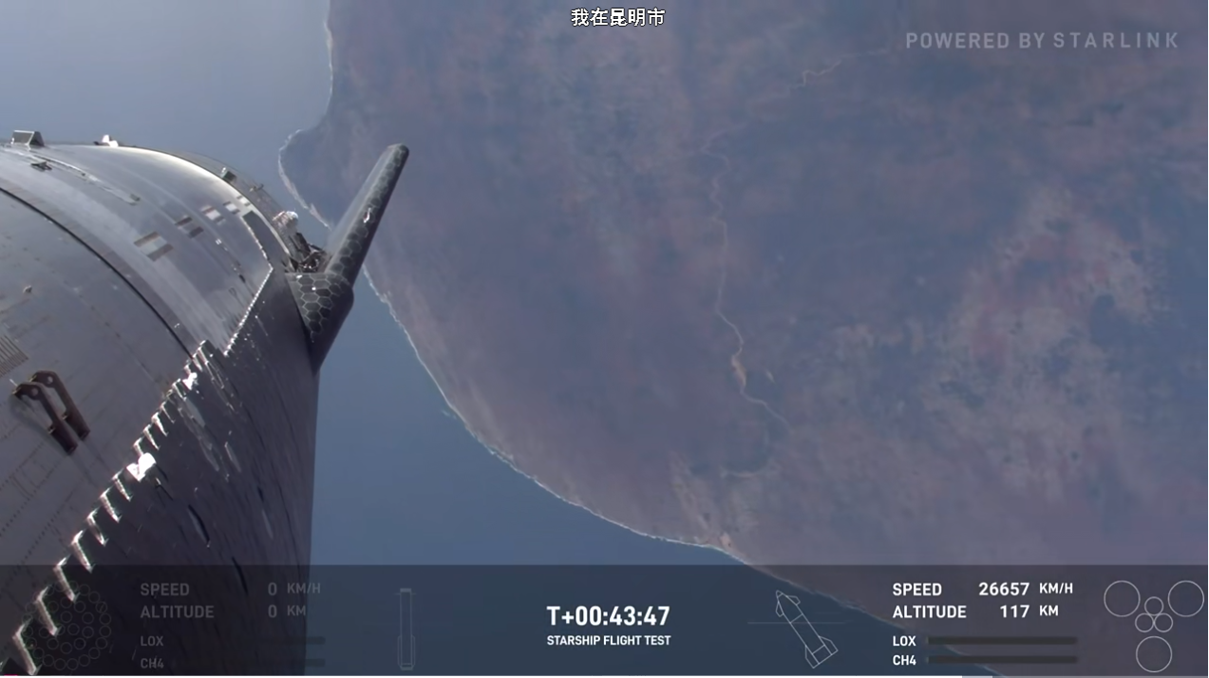

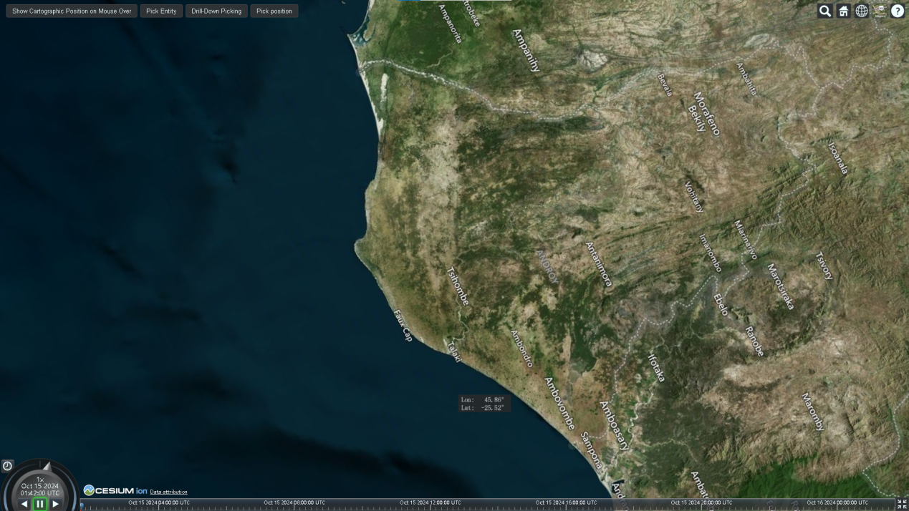

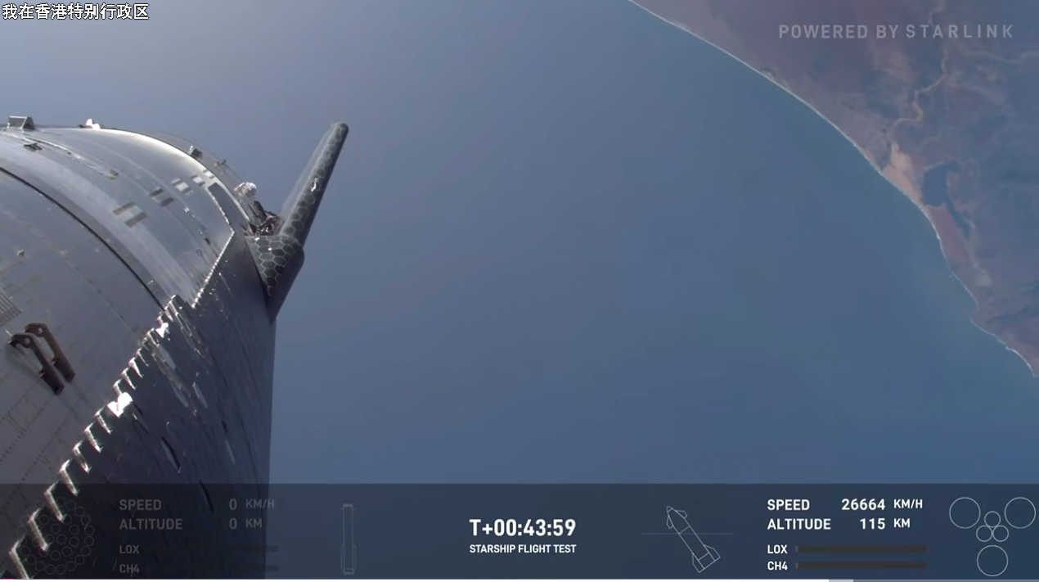

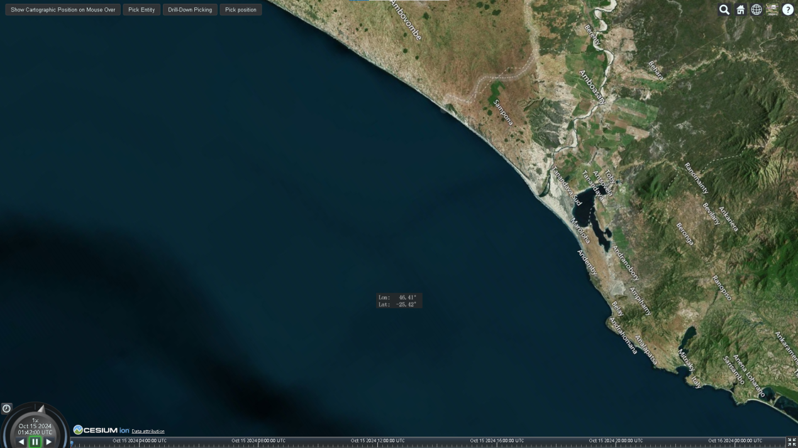

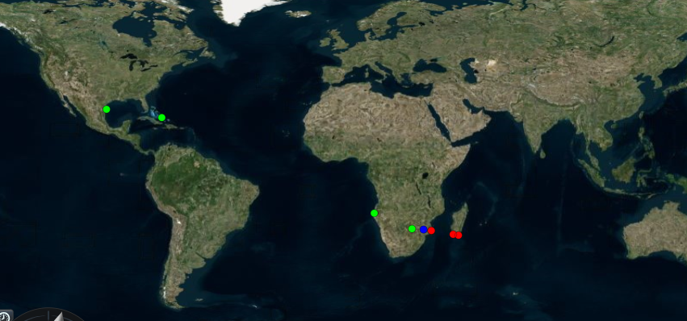

viewer.entities.add({

position: Cesium.Cartesian3.fromDegrees(46.41, -25.42),

point: {

color: Cesium.Color.RED,

pixelSize: 8,

},

});

viewer.entities.add({

position: Cesium.Cartesian3.fromDegrees(44.23, -25.06),

point: {

color: Cesium.Color.RED,

pixelSize: 8,

},

});

viewer.entities.add({

position: Cesium.Cartesian3.fromDegrees(35.34, -23.53),

point: {

color: Cesium.Color.RED,

pixelSize: 8,

},

});

viewer.entities.add({

position: Cesium.Cartesian3.fromDegrees(32.15, -23.08),

point: {

color: Cesium.Color.BLUE,

pixelSize: 8,

},

});

viewer.entities.add({

position: Cesium.Cartesian3.fromDegrees(27.45, -22.79),

point: {

color: Cesium.Color.LIME,

pixelSize: 8,

},

});

viewer.entities.add({

position: Cesium.Cartesian3.fromDegrees(12.05, -16.41),

point: {

color: Cesium.Color.LIME,

pixelSize: 8,

},

});

viewer.entities.add({

position: Cesium.Cartesian3.fromDegrees(-74.61, 22.62),

point: {

color: Cesium.Color.LIME,

pixelSize: 8,

},

});

viewer.entities.add({

position: Cesium.Cartesian3.fromDegrees(-97.15, 26.00),

point: {

color: Cesium.Color.LIME,

pixelSize: 8,

},

});

const pointsOfInterest = [

{

text: "Apollo 11",

latitude: 0.67416,

longitude: 23.47315,

},

{

text: "Apollo 14",

latitude: -3.64417,

longitude: 342.52135,

},

{

text: "Apollo 15",

latitude: 26.13341,

longitude: 3.6285,

},

{

text: "Lunokhod 1",

latitude: 38.2378,

longitude: -35.0017,

},

{

text: "Lunokhod 2",

latitude: 25.83232,

longitude: 30.92215,

},

{

text: "change 4",

latitude: -45,

longitude: 178,

},

{

text: "change 3",

latitude: 44.12,

longitude: -19.51,

},

{

text: "change 5",

latitude: 43,

longitude: -52,

},

];